SPRITES ARE CHEAP

Writing a retro-style game in JavaScript

Krzysiek D.
Is writing a 2D game easier nowadays than 30-40 years ago?

Do current tools allow us to easily create and manage sprites?

Are sprites cheap nowadays?

SCHEDULE

- Introduction – what are sprites & JS

- PHASER library + setup

- Live coding:

static sprite
multiple sprites
sprite movement
animated sprite
sprite controls
collisions
score

- Summary

1.Java Script

- programming language used to create interactive websites
- runs in web browsers to add dynamic content and features
- can also be used for server-side development with tools like Node.js
- created by Brendan Eich in 1995 (as LiveScript) and has become a fundamental technology of the web
- easily available from browser console

2.PHASER

- open-source JavaScript library used to create 2D games for web browsers
- framework for rendering graphics, handling input, and managing game physics
- known for its ease of use, extensive documentation, and active community support.

PHASER SETUP
  - Create an HTML page
  - Include this link to phaser.js in your page
https://cdn.jsdelivr.net/npm/phaser@3/dist/phaser.js
<html>
<head>
<script src="https://cdn.jsdelivr.net/npm/phaser@3/dist/phaser.js"></script>
</head>
</html>

  - Create an HTML div to display the game
<body>
<div id="game-container"></div>
</body>

  - Add JS section with phaser parameters
<script>
const config = {
type: Phaser.CANVAS, // rendering style (WebGL or Canvas)
width: 800,
height: 600,
parent: 'game-container'
};
</script>

  - Create game object
const game = new Phaser.Game(config);

Full code so far: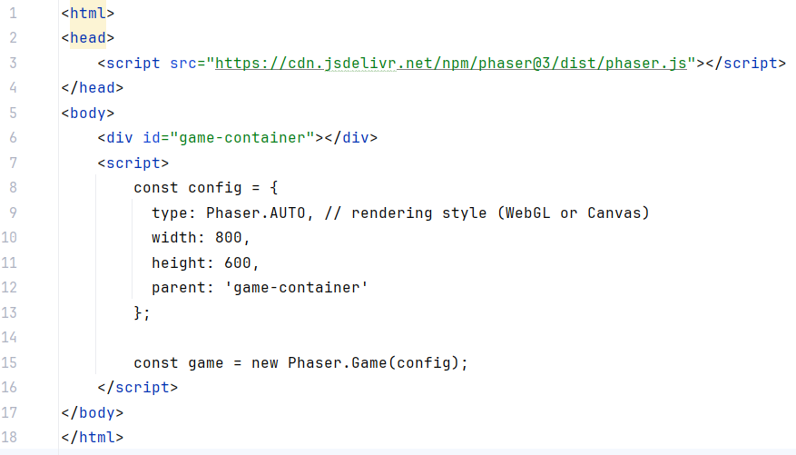
  - Add default scene and functions preload (), create() and update
function preload(){
}
function create(){
this.add.text(20, 20, 'Super fajna gra!', { font: '24px Arial', fill: '#ffffff' });
}
function update(){
}

scene: {
preload: preload,
create: create,
update: update
}

  - Adding a sprite
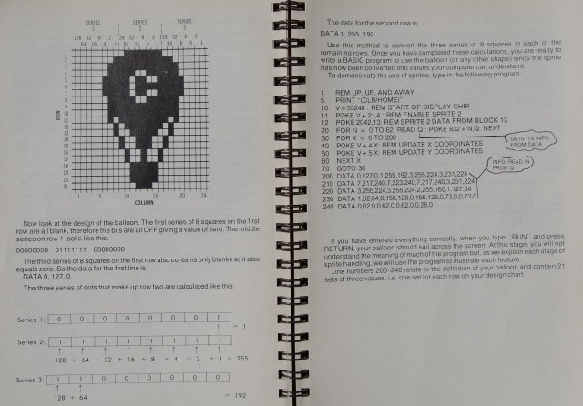
Our sprite:
- No need to define individual pixels
- Use PNG, BMP, JPG pictures instead:

balloon.png



Simple code to add a sprite:
let sprite = null;
function preload() {
this.load.image('balloon', 'balloon.png');
}
function create() {
this.add.text(20, 20, 'Super fajna gra!', { font: '24px Arial', fill: '#ffffff' });
sprite = this.add.sprite(200, 200, 'balloon');
}

Sprite can be modified from browser console, using ‘sprite’ variable
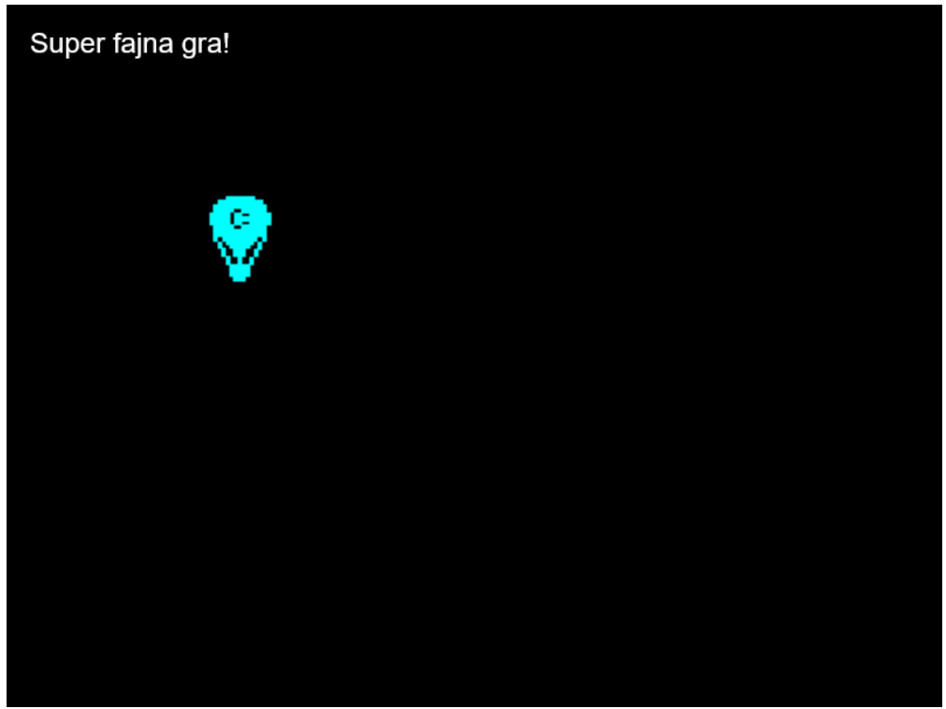
3.2 Create 12 sprites:
const spritesCount = 12;
let sprites = [];

function create() {
this.add.text(20, 20, 'Super fajna gra!', { font: '24px Arial', fill: '#ffffff' });
for (let i = 0; i < spritesCount; i++){
let s = this.add.sprite(i, 50*i, 'balloon');
sprites.push(s);
}

3.3 Let’s get movin’...
function update() {
for (let i = 0; i < spritesCount; i++){
if (sprites[i].x < 800)
sprites[i].x += i; //(i+1) % 20;
else
sprites[i].x = 0;
}
}

3.4 Introducing player

Animated player sprite



let player;
function preload() {
this.load.image('balloon', 'balloon.png');
this.load.spritesheet('digdug', 'empty-project/dig-dug.png', {
frameWidth: 75,
frameHeight: 75
});
}

Animating player
function create() {
//……….
player = this.add.sprite(400, 300, 'digdug');
this.anims.create({
key: 'walk',
frames: this.anims.generateFrameNumbers('digdug', { start: 0, end: 3 }),
frameRate: 5,
repeat: -1
});
player.play('walk');
}

3.5 Moving player
function update(){
//….
checkKeys();
}
let cursors;
function create(){
//….
cursors = this.input.keyboard.createCursorKeys();
}

function checkKeys(){
if (cursors.left.isDown) {
player.x -= 1;
} else if (cursors.right.isDown) {
player.x += 1;
}
if (cursors.up.isDown) {
player.y -= 1;
} else if (cursors.down.isDown) {
player.y += 1;
}
}

3.6 Collisions
function checkHit(sprite){
let d = Phaser.Math.Distance.Between(sprite.x + sprite.width/2, sprite.y + sprite.height/2
, player.x + player.width/2, player.y + player.height/2);
if (d < 20){
sprite.y = Math.pow(10,16);
}
}

3.7 Score
<div id="score">SCORE: 0</div>

…………
function increaseScore(){
score++;
const scoreDiv = document.getElementById('score');
scoreDiv.innerText = 'SCORE: ' + score;
}

4. Summary

- It is possible to quickly write a simple game using JS Phaser

- Phaser library significantly facilitated sprites creation and handling

- JavaScript with Phaser is a good tool to write a retro-style game

